

March 2, 2022, 4:15 pm

Board of Directors Meeting Minutes

Zoom

_____________________________________________________________________________________

In attendance: Diane Boston, Meredith Edwards, Jennifer Foster, Carol Glassmeyer, Maeve McGovern, John Sini, Tammy Sload, Lauren Swenson, Tiffany Van Elslander

Absent: Stephen Berger, Richard Chilton, Ron Lamorte, Penny Rashin, Carolyn Woodberry

Approval of January minutes – minutes available online. Approved …

Nominating/Governance – Jennifer, Carolyn, Lauren

* Heather recommended we consider Susan Wilson. She will be rolling off as head of ABC Darien – could help create programming in coordination with ABC. Heather will follow up.

2021 Financials

* Heather recommended $25,000 contribution to endowment from profits last year based on the following analysis:

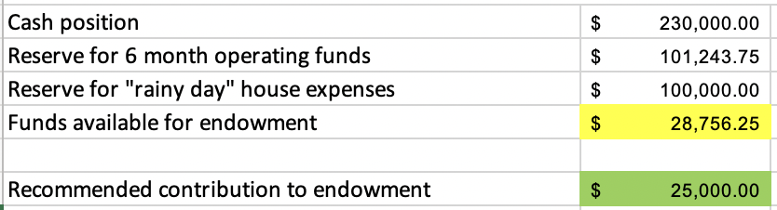

* + Is this the right amount to pull? Everyone agrees $25K is the right amount
  + Meredith - Should we instead use for beautification? Yes this is also an important priority and we could launch a campaign asking people to help match the $25K contribution by the foundation.
  + Tiffany – should we be super conservative before we get condition assessment back? Wait before restricting the funds.
  + Board agreed to WAIT to restrict funds until we have better visibility on potential house expenses. Then decide whether to use for endowment or beautification.
* Need to finalize endowment document (online)
  + A few details about endowment: Draw up to 5%, for property and care, clearly states no mission creep … e.g., board can’t use for future pet projects
  + Need to complete draft document from 2020 and vote as a board
  + John Sini and Jennifer will both review the draft that Heather will send out.

2022 Budget

* Approved budget with ~$500 profit for 2022 – John motion, Tammy second, all in favor. We discussed all of the assumptions. Diane had one concern if landscaping is high enough – are we depending too much on Andy’s free labor?! We said this is a conservative budget. We hope for upside on the top line which will enable us to spend more on landscaping projects.

Survey & Planning Grant Update – Diane

* Heather, Diane, Penny are reviewing contract with APS (Architectural Preservation Studios, Carl & Rose). We will ask Kevin Treesh to also review.

Audience Assessment – Survey Update – Heather, Meredith, Diane, Tammy

* Heather to send survey to board for review. Please comment on length, any specific issues, and most importantly, are we answering the right questions?
* Diane – the voice of Mather is coming through. Heather - Need to make sure it is still coming through after recent cuts.

Buildings & Grounds – Heather

* Recent projects:
  + Propane tank gone, fence to be removed on Friday.
  + Waste line to be fixed next week.
  + Apple TV added in the barn – no more issues of cords not working when we try to project a presentation!
  + All outdoor posts now on timer – dusk to dawn.
  + Fan ordered for upstairs in barn – just one we hope will fix problem.

Archiving/Curatorial

* In progress:
  + Archiving project – Donn Smith & Tammy Berentson, Hal Miller & Connor Gregory
  + Stephen Tyng Mather Exhibit – Kathy Craughwell-Varda

P&Z – John

* Working on P&Z document
* 4-6 weeks
* Will have to notify neighbors and do neighbor meetings. (100 yards?) Send registered mail.
* Asking for:
  + Increase the maximum number of visitors permitted on the site from 150 to 250.
  + For the five permitted ***large events***, increase the maximum participation limit from 150 to 250 visitors at any given time. (Note: These large events would typically be outdoor events occurring during the months of May through October.)
  + For ***mid-size events***, increase the number of annual occurrences from ten to fifteen and increase the maximum participation limit in these events from 70 to 130 visitors. 130 is maximum allowed in the barn due to fire code.
  + For ***small events***, permitted to occur on an unlimited basis throughout the year, increase the maximum participation limit from 30 to 60 visitors. This figure is typical of the number of visitors that would arrive on a school fieldtrip with two busses.
  + Add a condition to require all outdoor events with amplified music/sound to end by 10 PM.
  + Amend Condition D: Remove the requirement for a submitted parking plan for each large event. Add the condition that parking for all large events shall require parking attendants/monitors and be located on the lawn and newly gifted field north of the cottage and the Brookside Road driveway entrance.
* Chair of P&Z doesn’t see problem.
  + We think main issues are around parking. Lighting of field at night. Filling in holes.

Upcoming events – would love your feedback!

* Event list online
* Update – ~150 attending Après Ski – huge thanks to Junior Board especially Lauren & Jessica Merrill, 107 attending Jonathan Olmsted – still 4 weeks to go!
* Heather to create easy invitation to pass on for Mather Tavern
* Diane – likes “Homesteading Workshops”
* Decision not to do Easter Egg Roll – too much competition; instead stick with Stephen Mather Birthday Party Games – need to improve the name of it. We can “own” old fashioned games. Think about family competition – form your own teams … e.g., team picks a park to represent. Ask Kathy Varda about themes from STM research. Mather plaque … could put the winner’s name on there every year.
* Candlelight dinner …we are USING the house! Also for book club, poetry.

Strategic Plan – how are we doing?

* Strategic Plan scorecard online. We are moving along and this scorecard will force a discipline of making sure we continue to be mindful of strategic plan.

Next meeting … DEVELOPMENT

* Development plan
* Development “case statement” – everyone to prepare
* Stewardship
* Endowment

2021 Meetings – 4:15 pm

* April 20 - ZOOM
* June 15 – LIVE in the garden
* July 20 – review financials, events from past year and event schedule for following year.