Kathleen Craughwell-Varda
______________________________________________________________________
Museum Consultant 6 Old Middle Road
Brookfield, Connecticut 06804
Telephone: 203-241-0618
Email: vardaconsulting@aol.com

July 12, 2022

To Protect & Preserve: Stephen Mather and the National Parks

Exhibit Script – Text Panel Copy

Exhibit Title Panel: To Protect & Preserve: Stephen Mather and the National Parks

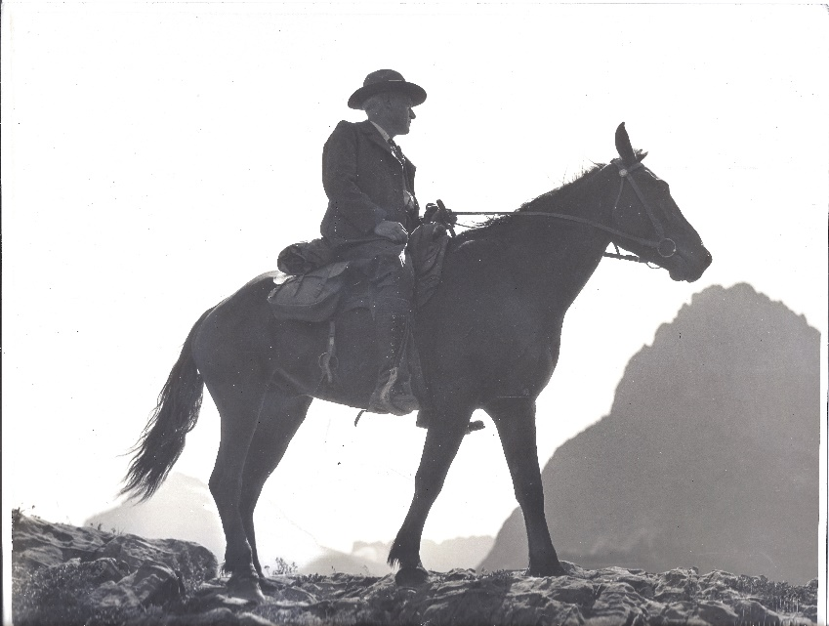

Stephen Mather inspecting the trails of Glacier National Park
The Mather Homestead Foundation

Exhibit Text Panel 1, Front: Introduction
Title: Stephen Mather and the National Parks

Between every two pine trees there is a door leading to a new way of life … Climb the mountains and get their good tidings. Nature’s peace will flow into you as sunshine into trees.
–John Muir, naturalist and early advocate of protecting the environment

The National Parks system we enjoy today is the result of the vision of one man–the charismatic and energetic Stephen Mather, the first director of the National Park Service. A self-made millionaire, with a passion for nature and its conservation, Stephen Mather retired early and dedicated his life to preserving and protecting America’s scenic landscapes. He is responsible for saving some of the best-known natural wonders and landscapes including Grand Canyon, Zion, Hawaii Volcanoes, Denali, Acadia, Hot Springs, and Shenandoah. All are National Parks because Mather recognized the importance of preserving these areas as a gateway for Americans to explore the natural wonders of this country.

Stephen Mather democratized access to the National Parks by making them affordable and open to all Americans. He launched a massive publicity campaign to encourage vacationers to take advantage of new campsites and lodgings at the National Parks, he made traveling to the parks affordable by partnering with the railroads, and he took a personal interest in designing scenic roadways through the parks, which coincided with the enormous popularity of the automobile.

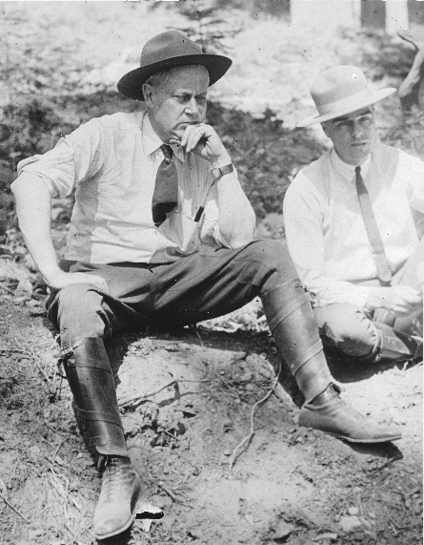

Stephen Mather
The Mather Homestead Foundation

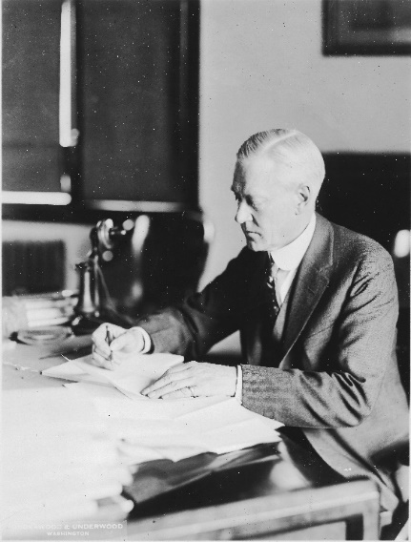

Stephen Mather in his office.
The Mather Homestead Foundation

Exhibit Text Panel 1, Back:
Title: The Mather Homestead and its Most Famous Resident

Stephen Mather’s came from an old New England family which arrived in Boston in 1635. Deacon Joseph Mather, Stephen Mather’s great grandfather, built the Mather Homestead in 1778. As a child, Stephen would travel with his family to Darien and visit his great-aunts at the family homestead. In 1906 he became the sole owner of the house and 22 acres. During his ownership, Mather nearly doubled the size of the house. A porch was added to the side leading to a new sunken garden, a two-story addition to the rear included a modern kitchen with bedrooms upstairs, and the portico over the main entrance was renovated. He also added a caretaker's cottage (replaced later by a guesthouse) and a carriage barn. The interior of the house retained its original character and finishes during these renovations except for the old kitchen, which was converted into a living room. Following Mather’s death in 1930, his daughter Bertha inherited the house, raising her three children with her husband Edward McPherson and living in the home until her death in 1993. McPherson remained in the home until his death in 2002 and the three siblings owned the home until 2017 when it was gifted to a newly created Mather Homestead Foundation.

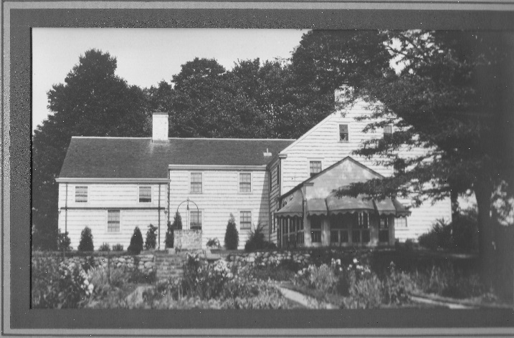

The Mather Homestead
The Mather Homestead Foundation
The Mather Homestead after the changes made at the direction of Stephen Mather.

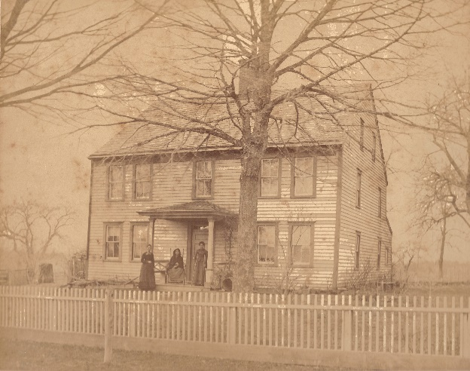

The Daughters of Deacon Mather
The Mather Homestead Foundation
This is the earliest known photograph of the Homestead.

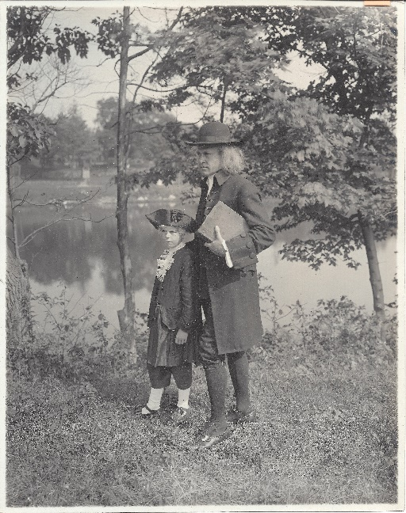

Stephen Mather Dressed as Deacon Mather
The Mather Homestead Foundation

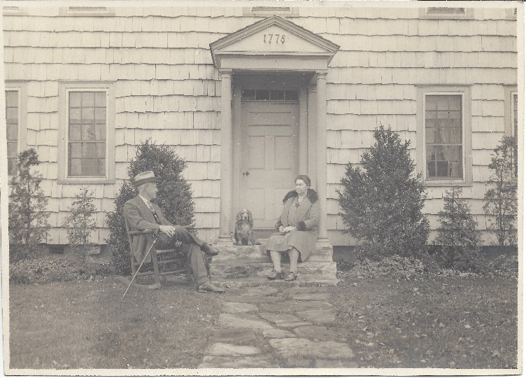

Stephen and Jane Mather Outside the Homestead
The Mather Homestead Foundation

Exhibit Text Panel 2:
Title: Early Life and Career

Stephen Tyng Mather was born July 4, 1867, in San Francisco to Joseph W. Mather and Bertha Jemima Walker–the first of his family born and raised on the west coast. He was named after the prominent Episcopal minister who had married his parents three years earlier in New York City. Two years later the Mather’s second son, Joseph was born. When Stephen was three years old, his mother suffered a bout of mental illness. She was hospitalized for three years and then returned to New York, residing with her sister. Although she never lived with her husband and children again, she maintained a close relationship with her sons, especially Stephen.

Following his graduation from the University of California at Berkeley in 1887, Mather traveled east to visit with his mother. While there, he took a job as a reporter at The New York Sun. His journalism career ended in 1893 when he married Jane Thacker Floy of Elizabeth, New Jersey. Their child, Bertha Floy Mather, shared a close relationship with her father and his interests in conservation and the national parks.

Early in his marriage, Mather accepted a job with Pacific Coast Borax Company at its headquarters in New York, where his father was also employed. In 1894, the younger Mather moved with his wife to Chicago. There he created the famous 20 Mule Team Borax branding logo for the company, making the product a household name and earning him a reputation as an advertising and promotions genius. In 1898, Mather helped a friend start a new borax company. Six years later, he joined his friend’s company, which they called the Thorkildsen-Mather Borax Company. An enterprising and competitive businessman, he became wealthy within a decade, retiring in his mid-forties (1914) to pursue other interests.

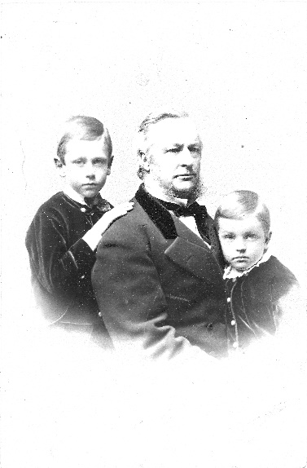
Stephen, Joseph and Joseph Mather, Jr.
The Mather Homestead Foundation
Joseph Mather, Jr. died at the age of 19 in 1888.

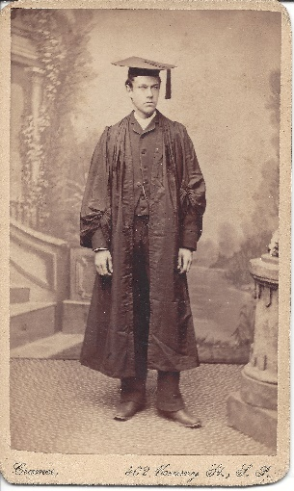

Stephen Mather
The Mather Homestead Foundation
Mather graduated from the University of California, Berkeley in 1887.

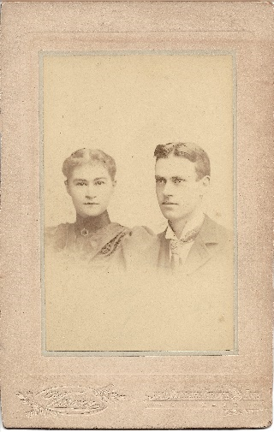

Jane Floy Mather & Stephen Mather
The Mather Homestead Foundation

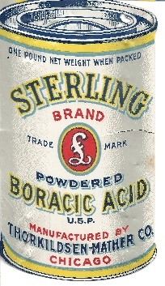

Thorkildsen-Mather Borax Company Advertising Card
The Mather Homestead Foundation

Exhibit Text Panel 2, Back:
Title: A Brilliant Man with a Debilitating Disorder

[T]his brilliant, creative, and successful man who was burdened with a mental condition that could burst upon him, without warning, when fatigue and stress mounted. His energy and exuberance, which accomplished so many great things, could turn to deep, silent, suicidal depression with little warning.
– Horace Albright

Stephen Mather was described as charismatic and generous, as well as indefatigable and a workaholic. At times he could be difficult, argumentative, even impetuous—characteristics of the bipolar disorder he struggled with for much of his adult life. Only his wife and closest associates knew of his “nervous episodes” and their severity. At least three times during his adult life, Mather had manic depressive episodes and each event was followed by a long recovery. The first known episode was in 1903 and was part of the reason his employment ended with Pacific Coast Borax Company. The second documented case was in 1917. Mather had been working for two years to create the National Park Service, managing a strenuous workload, and traveling constantly. Shortly before he was sworn in as director of the National Park Service, Mather had a manic-depressive episode that put him on suicide watch. While his deputy, Horace Albright, served as acting director, Mather was hospitalized to recover his mental health. Eventually his doctors sent him to the Hot Springs in Arkansas (before it became a National Park), hoping it would restore his health. Mather recovered and recognized, before it was a recommended treatment, the restorative impact of nature on his mental health.

Work, stress, and worry were contributing factors to these episodes. His boundless energy and frenetic pace were also a result of his bipolar disorder, but had a remarkable impact on the National Parks by providing the drive that allowed him to accomplish so much in a short amount of time.

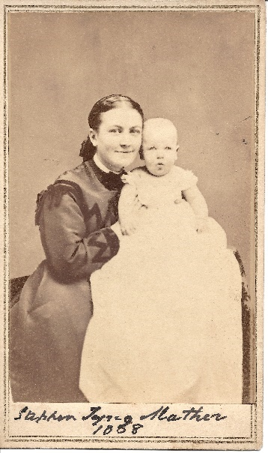

Bertha Walker Mather with son Stephen Mather, 1868
The Mather Homestead Foundation
Both mother and son struggled with mental health challenges.

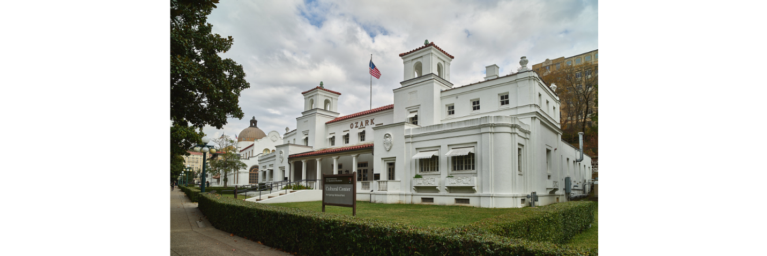

The Ozark Bathhouse, now the cultural center of the Hot Springs National Park along "Bathhouse Row.”
Library of Congress Prints and Photographs Division Washington, D.C.
Stephen Mather built bathhouses for the public when Hot Springs became a National Park.

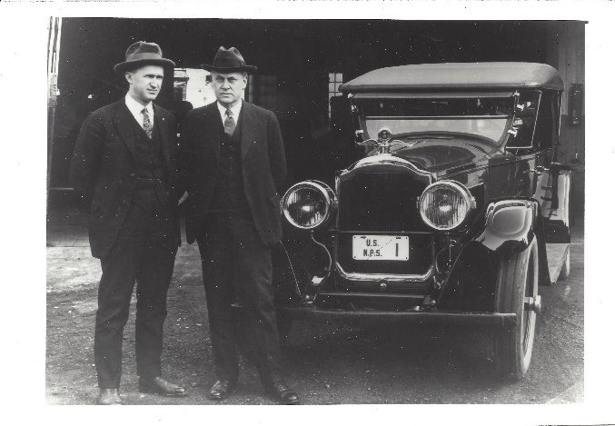
Horace Albright and Stephen T. Mather
The Mather Homestead Foundation
During Mather’s episodes with depression, Albright managed the National Park Service.

Exhibit Text Panel 3:
Title: Conservation and the National Parks

Stephen Mather’s formative years in California inspired his love of nature. While he only lived in California for the first 20 years of his life, he had a lifelong love for the mountain ranges of his native state and would always take friends and associates through California’s National Parks to inspire their support.
Mather’s interest in national parks was influenced by a 1904 trip to Europe he took with his wife. Climbing the Swiss Alps and seeing how accessible they were to visitors inspired Mather to bring this model to park management in the United States. On his return, he became a dedicated conservationist, a friend and admirer of the influential John Muir, joined the Sierra Club, and climbed Mount Rainier. Through his activities in the Sierra Club Mather made numerous allies who supported the creation of the National Park Service. In 1916, the Sierra Club made him an honorary vice-president.
Following his retirement from the borax industry, Mather found the perfect outlet for his boundless energies. After criticizing the Interior Department’s administration of the National Parks, Secretary Franklin K. Lane invited Mather to come to Washington, D.C. to serve as the special assistant for national park concerns. His vigorous efforts to build public and political support for the parks led to President Woodrow Wilson signing the bill that authorized the National Park Service in August 1915. Two years later, Mather was appointed its first director.

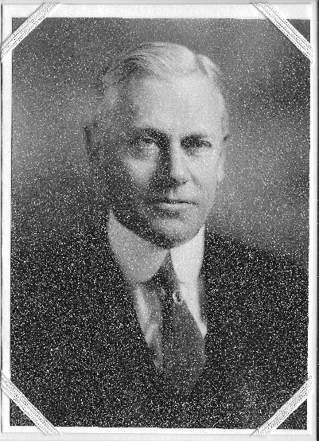

Stephen Mather
The Mather Homestead Foundation

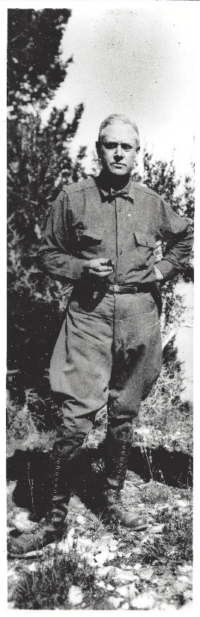
Stephen T. Mather
The Mather Homestead Foundation

Exhibit Text Panel 3, Back:
Title: The Mather Mountain Party

In his first 12 months as special assistant for national park concerns to the Secretary of the Interior, Mather worked the corridors of Washington, D.C., traveled 30,000 miles, and hosted one of the most spectacular lobbying sessions in American history. Nineteen politicians, businessmen, and scientists, along with the vice-president of the Southern Pacific Railroad, the editor of National Geographic, the president of the American Museum of Natural History, and a congressman, who later became the Speaker of the House, accepted Mather’s invitation for a two-week camping trip in July of 1915 through the Sierra Nevada mountains. Known as the Mather Mountain Party, the purpose of the trip was to lobby this captive audience to support the creation of the National Park Service.

Mather paid for the entire trip, hiring touring cars, horses, mules, and providing everyone with the latest in camping comfort–an air mattress. He hired a cook to prepare gourmet meals served on white linen tablecloths with fine china in remote areas of the park. In addition to having a memorable experience, the members of the Mountain Party saw the poor conditions of the campsites, the barely passable roads, the vulnerability of the ancient Sequoia groves to logging interests, and how grazing cattle were decimating meadows. At the end of the trip, Mather said to the group:

I think the time has come … that I should confess why I wanted you to come along with me on this adventure–not only for your interesting company, but to hope you’d see the significance of these mountains in the whole picture of what we are trying to do. Hopefully you will take this message and spread it throughout the land in your own avenue and style.

In the end, Mather’s charisma coupled with the amazing scenery of the Sierra Nevada mountains created a memorable trip that won everyone over. Back in Washington, D. C., the men from the Mather Mountain Party lobbied successfully to create the National Park Service.

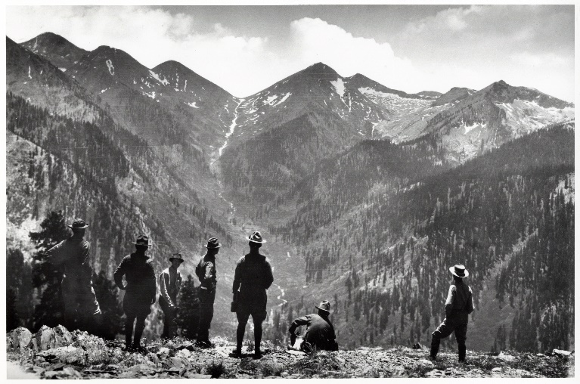
Entering Mineral King Valley
NPS History Collection, HFCA-01210

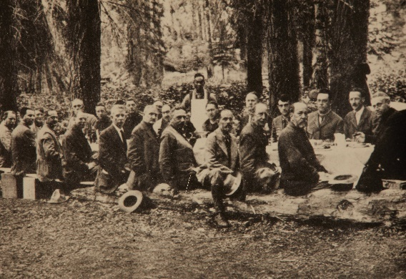

Dinner at Giant Forest
NPS History Collection, HFCA-01210
Stephen Mather sits at the head of the table.
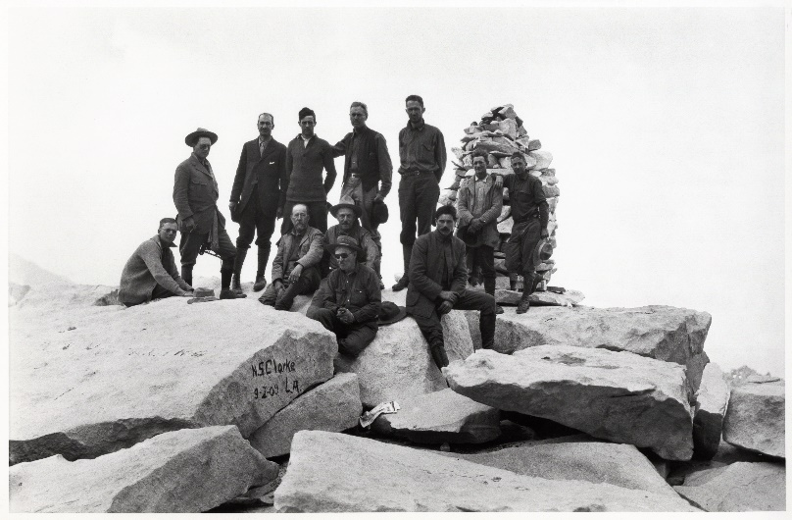

On the Summit of Mount Whitney
NPS History Collection, HFCA-01210

Exhibit Text Panel 4:
Title: Creating the National Park Service

In 1872, Congress established Yellowstone as the first national park. More would follow, but these early efforts to preserve the awe-inspiring wildernesses in this country were inconsistent and lacked forward thinking. As with many well-intentioned efforts of the late 19th century, there was frequently an industrialist or businessman who took advantage of the benign neglect of the parks for their own financial benefit. It took Stephen Mather, who had a great interest in conservation, to create a working system to protect and expand the National Parks.

Stephen Mather wasted no time in launching his new department. Realizing that the budget for the National Parks was too small to cover the work he deemed necessary, Mather augmented the department’s financial resources with his own funds. He purchased lands and donated them to the National Parks. He supplemented the salary of senior staff and provided bonuses and vacation pay. He immediately hired two men who would be instrumental in making his plans a success--Horace Albright, as his deputy and right-hand man, and Robert Sterling Yard, former co-worker at The New York Sun and friend, to publicize the parks and promote American tourism. Mather realized that Congress was not going to authorize adequate funding for the National Parks until the American people demanded it and that the people would not do much demanding until they had been introduced to the parks.

In preparation for new tourists to the parks, Mather initiated the development of lodges and campsites, as well as railroad access and new roadways to make normally remote areas more accessible to visitors. He was also firm in preventing any private development in the parks that would mar its natural beauty, including preventing the building of a cable car across the Grand Canyon. In addition, he created the Park Rangers, men and women who were charged with protecting the parks and interacting and educating visitors.
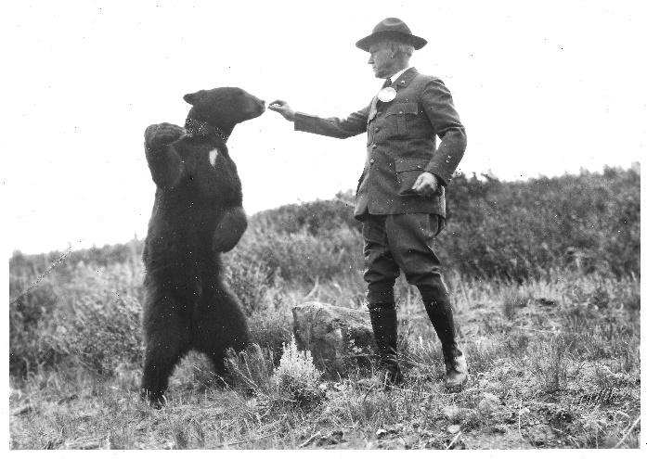
Stephen Mather Feeding a Bear
The Mather Homestead Foundation

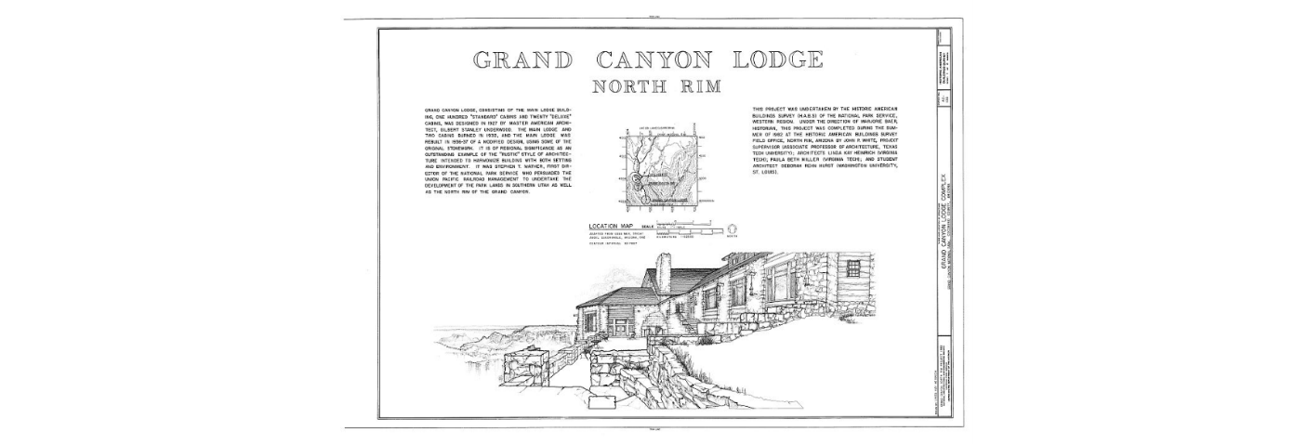

Grand Canyon Lodge, North Rim, Grand Canyon
Library of Congress Prints and Photographs Division Washington, D.C.

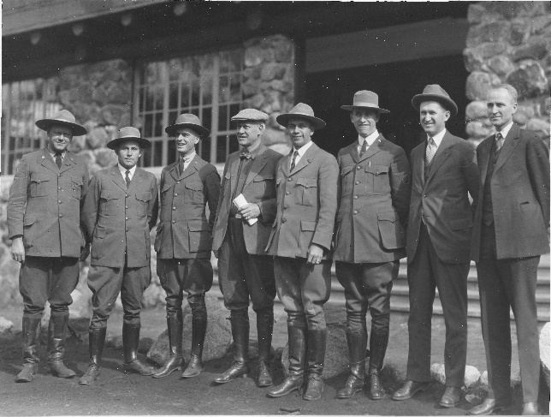

Stephen Mather with Park Rangers.
The Mather Homestead Foundation

Exhibit Text Panel 4, Back:
Title: Native Americans and the National Parks

When you walk into any … national park you’re walking into somebody’s homeland … you’re not walking into a wilderness area, you’re walking into someplace that has been utilized for generations upon generations in every form you could imagine.
—Gerard Baker, National Park Service superintendent (retired), member of Mandan-Hidatsa tribe

Years before the first National Park was created, the United States government forcibly removed Native Americans from their lands. Much of the 85 million acres of land in the National Parks were once the homeland of Indigenous people. Some of the lands, such as Grand Canyon, Glacier, Badlands, and Mesa Verde, include evidence of human presence thousands of years before white settlers arrived and include lands and natural features sacred to Native Americans.

Stephen Mather was not actively involved in removing Native Americans from park lands, but his relations with Indigenous people does demonstrate some paternalistic tendencies. For example, in 1895, the federal government forced the Blackfeet Nation to sell their native land. Fifteen years later, when this area became Glacier National Park, the hunting and fishing rights the Blackfeet retained under that agreement were stripped from them. Mather and his deputy, Albright, met with chiefs of the Blackfeet people, but neither the substance nor outcome of that meeting is known.
As part of his plans to attract tourists to the National Parks, Mather approved staging battles between “cowboys and Indians,” stampeding bison through the parks, and allowing Native people to be dressed in Hollywood-style costumes and performing songs and dances white tourists expected to see. Mather did denounce the renaming of native lands that were part of the National Parks. He also fought for Mesa Verde to become a National Park, the first cultural heritage site selected thereby protecting the more than 600 Indigenous cliff dwellings and other archaeological features.
After decades of contentious relations, the people of the National Park Service have made concerted efforts to collaborate with the tribes who have ties to park lands, to promote tribal culture and voices, to include tribal members in the visitor education experience, and to invite their participation and input in the preservation of their ancestral land.
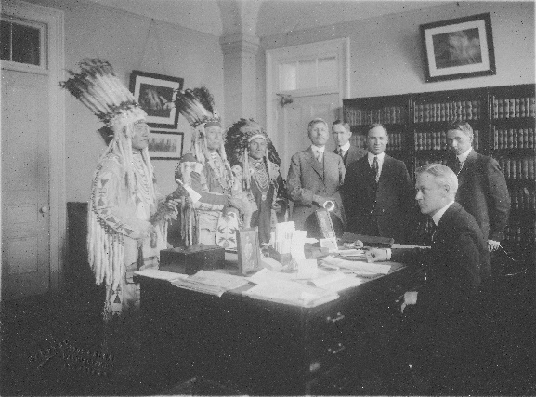
Stephen Mather & Horace Albright Meeting with Chiefs of Blackfeet Nation
The Mather Homestead Foundation

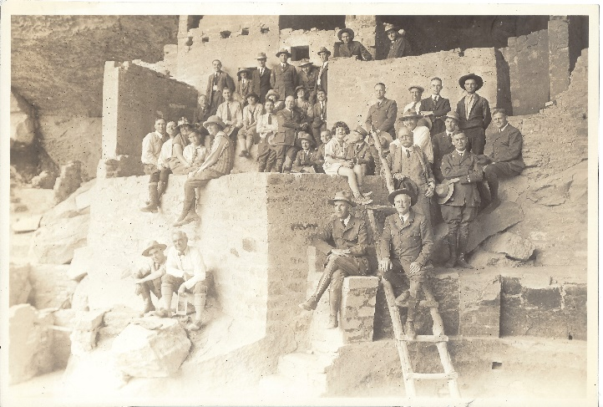
Stephen Mather at the Cliff Palace Ruins, Mesa Verde National Park
The Mather Homestead Foundation

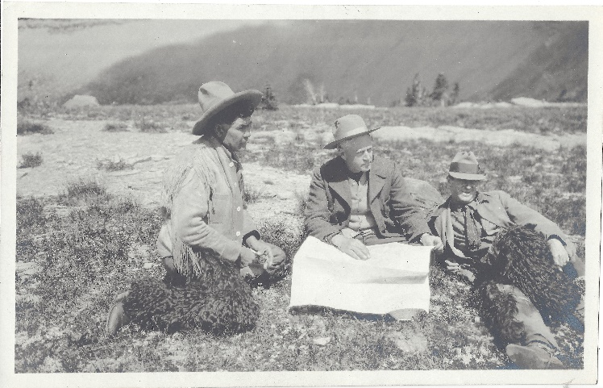

Stephen Mather at Glacier National Park
The Mather Homestead Foundation

Exhibit Text Panel 5: Conclusion
Title: An Enduring Legacy

He laid the foundation of the National Park Service. Defining and establishing the policies under which its areas shall be developed and conserved unimpaired for future generations. There will never come an end to the good that he has done.
- – inscription on Stephen Mather plaques

In 1927, ten years after he became director of the National Park Service, Stephen Mather suffered a heart attack. A month later, he was mountain climbing and back at his desk maintaining his frantic work schedule. He retired one year later after he suffered a massive stroke that left him incapacitated. He died January 22, 1930, and was buried in the family cemetery in Darien, Connecticut. The National Park Service acknowledged the deep debt they owed Stephen Mather by installing bronze plaques dedicated to his memory in every National Park and naming key natural features in several parks after him, including Mather Point at Grand Canyon’s south rim.

Stephen Mather recognized the need for and met the challenge of creating a National Park system. He expanded the park lands and establishing the first parks in the East, established professionals to manage the parks, and prevented industries from destroying park resources for their own gain. Most importantly, he welcomed Americans and encouraged them to experience the natural wonders of their country. Mather and Albright, his successor as director of the National Park Service, created an agency that Americans support, and which conservationists recognize for having preserved and protected lands that are valued for their aesthetic and spiritual value.

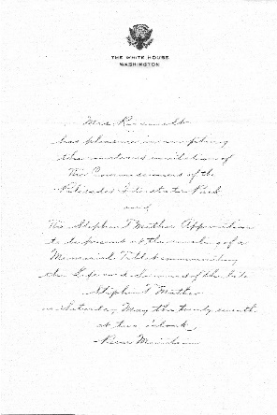

Letter from Roosevelt White House
The Mather Homestead Foundation
Eleanor Roosevelt accepted an invitation to attend the unveiling of a tablet commemorating Stephen Mather at Bear Mountain, New York.

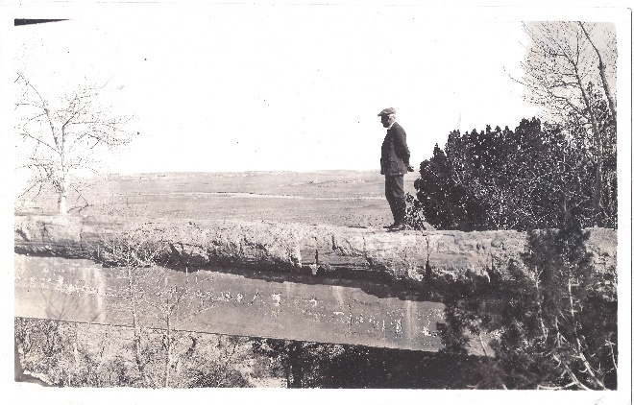
Stephen Mather on a Natural Bridge
The Mather Homestead Foundation

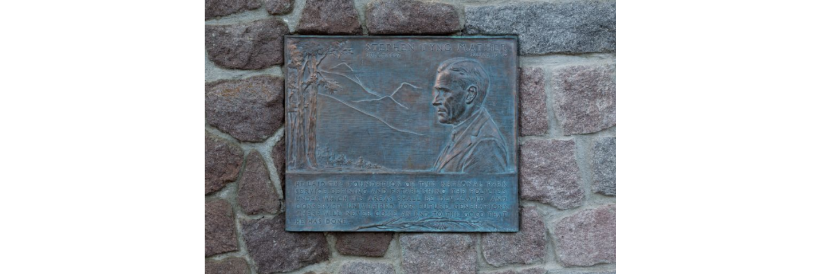

Stephen Mather Plaque
Library of Congress Prints and Photographs Division Washington, D.C.

Mather National Parks – images from Cavan

These photos will be used by Johanna in her exhibit design. More have been selected then we probably need.

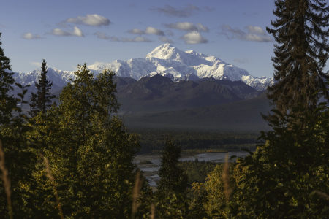 Denali
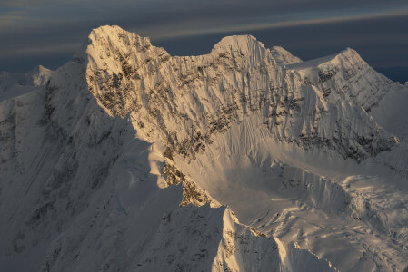 Denali
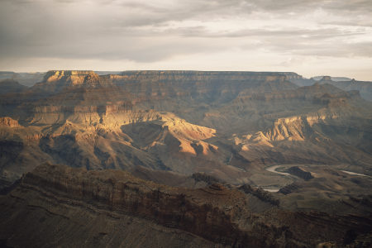 Sunrise from Mather Point, Grand Canyon
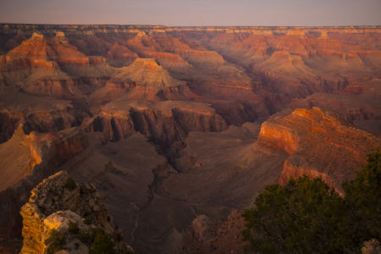 Grand Canyon
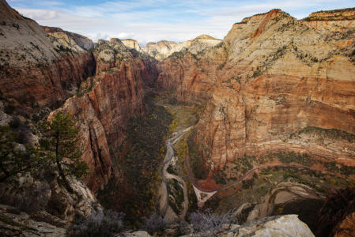 Zion
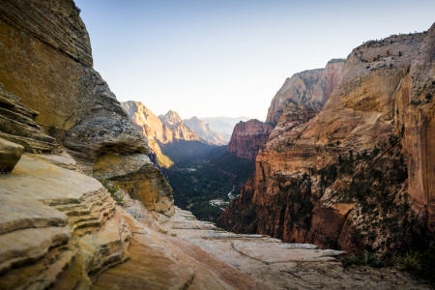 Zion
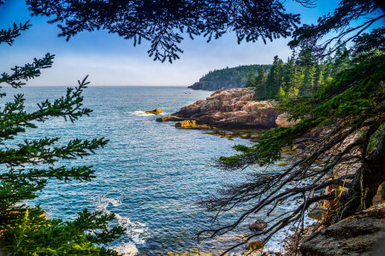 Acadia
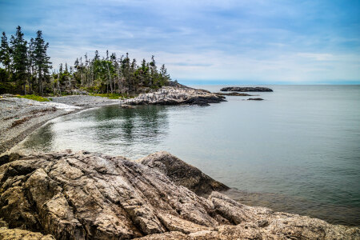 Acadia
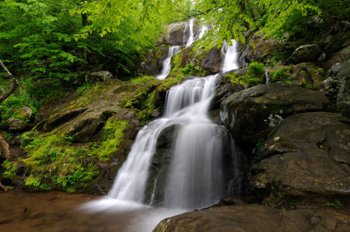 Shenandoah
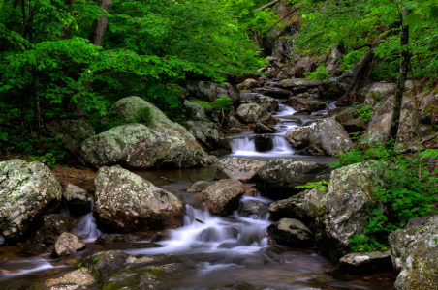 Shenandoah
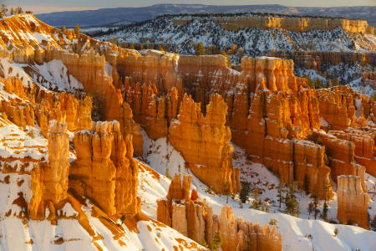 Bryce
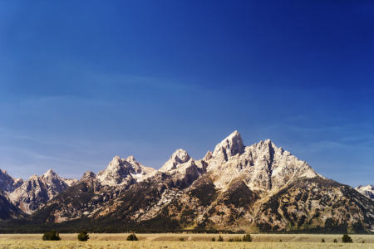 Grand Teton
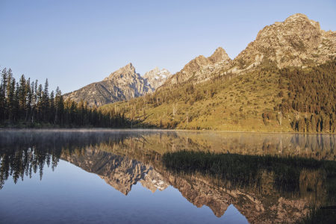 Grand Teton
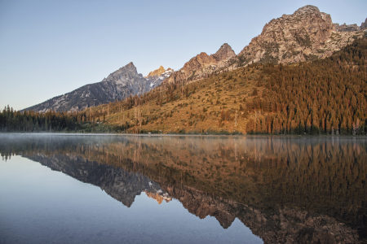 Grand Teton
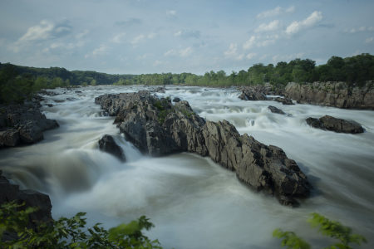 Mather Gorge, Near Washington, D.C.
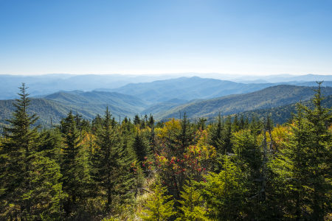 Smoky Mountain
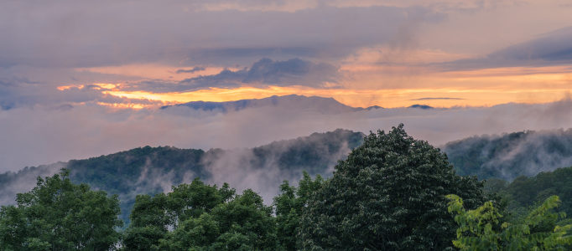
Smoky Mountain
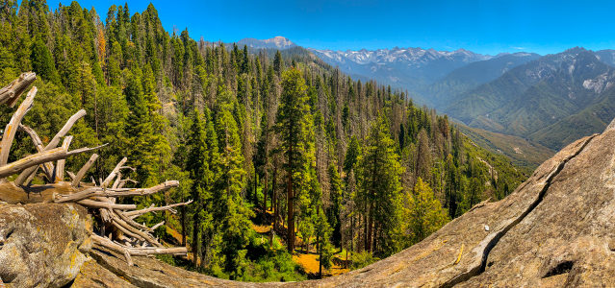 Sequoia
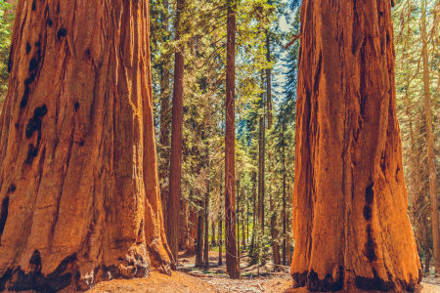
Sequoia

